ICE Task 2

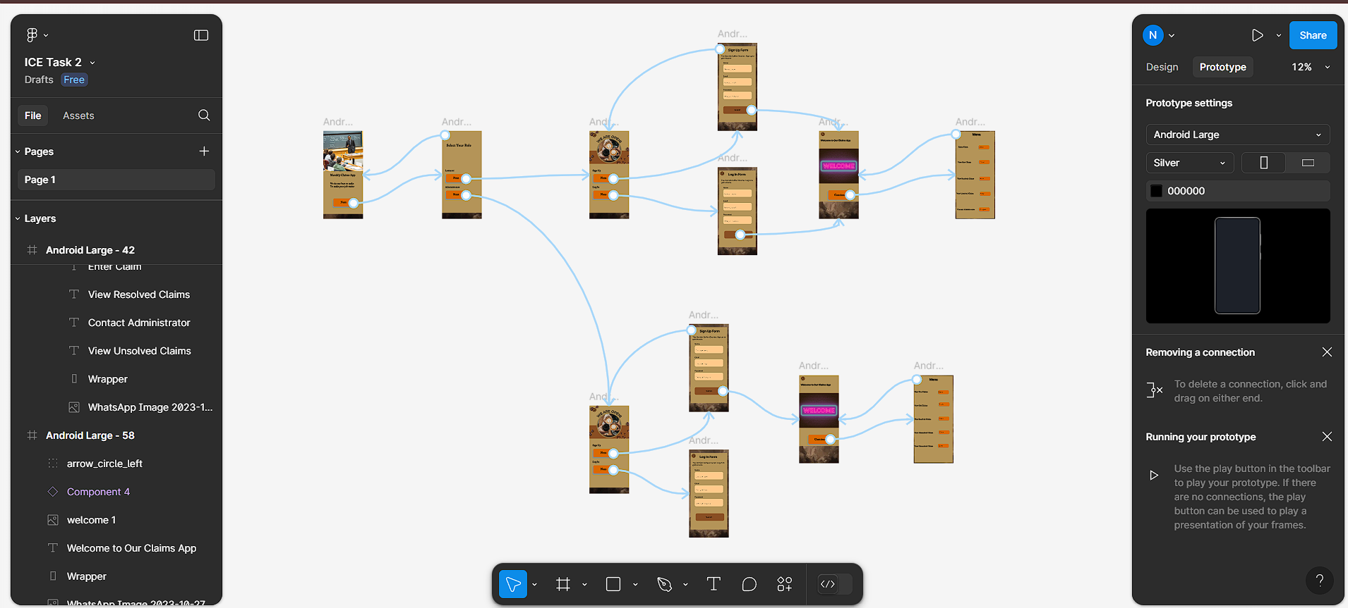

Link:

<https://www.figma.com/design/xgXaz9FgEHhGzMwjdVEfIL/ICE-Task-2?node-id=0-1&t=FYlSkHfOljdp3BVs-0>